

**DEPERTMENT OF INFORMATION COMMUNICATION TECHNOLOGY**

**OPTION OF INFORMATION TECHNOLOGY**

**TOPIC: SMART SERVER RACK MOUNT IOT SECURITY**

**CASE STUDY: IPRC KIGALI SERVER ROOM**

Submitted in partial fulfillment of the requirement for the award of Advanced Diploma in Information Communication Technology, Information Technology.

Supervised By:Presented By:

INEZA YvesNIYIGABA Claude

MUHETO Hodal

Kigali, December 2022

# CERTIFICATE

The project work presented this thesis entitled “**Design and Implementation Opening and Closing Server rack**er **mount IOT Security**“is record of the original work done by:

1 **MUHETO Hodal** Reg No **: 19RP10309**

2 **NIYIGABA Claude** Reg.No: **19RP04454**

In partial fulfillment of the requirement for the award of A1 Advanced Diploma in Information Communication Technology in IPRC KIGALI during Academic year 2021-2022

Supervisor Head of department

**INEZA Yves** **SABUSHIMIKE Donatien**

 Signature: ……………

# DECLARATION

MUHETO Hodal andNIYIGABA Claudedeclare that the content of this project is our original work and contribution to the fulfillment of the requirements for the award of Advanced Diploma in Information Communication Technology. We declare that this project is original and has never been presented for any academic award in our school as whole or in part. All the resources of information are clearly acknowledged by means of references.

MUHETOHodal

Signature: ………

NIYIGABA Claude

Signature: ………….

# DEDICATION

We are happy to dedicate this project to:

Our lovely parents

Our lectures and their assistants

Brothers and sisters

Our friends and colleague, we recognize all the valuable things you gave to us; your determination you showed us and support we have got from you.

We all dedicate you with many thanks for everyone who has been participated giving us any contribution accordingly!

# ACKNOWLEDGEMENT

First and foremost, we would like to thank God for giving us the strength and ability to carry out this project. We would like also to appreciate our Head of Department and all lecturer for their kindness and continuous support.

We extend special gratitude to our supervisor INEZA Yves for the supervision, his efforts and heartily guidance in bringing this book to its high state of excellence. He is not only dynamic supervisor but wonderful person. Our gratitude and sincere thanks are to our friends and colleagues who helped us in one way or another that drove us to who we are becoming. Finally, we wish to express our gratitude to our classmates who have contributed their effort during our work.

# ABSTRACT

Ordinarily Specialists are planned to limit society's troublesome by tracking down potential answers for those holes, for that we chose to help those individuals who are experiencing opening and shutting entryway physically by giving web application control a server lock control where client are mentioned to login through web application and he/she can have the option to open and close the server lock.

Our project is named "SMART SERVER RACK MOUNT". This proposition depicts the improvement of an IOT application in light of Digitizing a brilliant entryway lock for making it associated with the web and ready to perceive representatives that work in the workplace. This proposition focuses fundamentally on the security perspectives by posting the ordinary security challenges in IOT frameworks overall and summarizing these difficulties to foster a utilitarian and secure item without any preparation. A microcontroller is picked for this undertaking and a test climate is worked to explore and foster the security breaks. Compositional plans are picked for the Programming interface being created. The last phase of this venture is finishing the improvement of the web application where client can login in the web application and gain admittance to the given server and can open it through this application moreover this web application will record the time client opened the server rack mount lock and the time shut the server rack mount lock to help the administrator in administration of servers and ensuring that every one of the subsystems created do speak with one another, to convey a useful and secure progression of the IoT framework.

# LIST OF TABLES

Table 1 Hardware And Software Requirement 11

# LIST OF FIGURES

Figure 1 Garage rack mount opener with siemens 6

Figure 2 secret rack mount opener 7

Figure 3 keypads system 8

Figure 4 Waterfall model 10

Figure 5 old user case diagram 17

Figure 6 current user case diagram 18

Figure 7 entity schema diagram 19

Figure 8 Admin dashboard flow chart 20

Figure 9 User dashboard 21

Figure 10 user case 22

Figure 11 circuit 23

Figure 12 homepage 24

Figure 13 login page 25

Figure 14 admin dashboard 26

Figure 15 add server 27

Figure 16 user dashboard 28

Figure 17 switch on 29

# LIST OF SYMBOLS, ACRONYMS AND ABREVIATIONS

IOT: Internet Of Things, 14

IPRC KIGALI: Integrated Polytechnic Regional College KIGALI, 2

MB: Mega Byte, 11

SSL: SMART SERVER LOCK, 1

Contents

CERTIFICATE i

DECLARATION ii

DEDICATION iii

ACKNOWLEDGEMENT iv

ABSTRACT v

LIST OF TABLES vi

LIST OF FIGURES vii

LIST OF SYMBOLS, ACRONYMS AND ABREVIATIONS viii

CHAPTER 1: INTRODUCTION 1

1.1 BACKGRAUND OF PROJECT 1

1.2 PROBLEM STATEMENT 2

1.3 MOTIVATION 2

1.4 HYPOTHESIS 2

1.5 OBJECTIVES OF PROJECT 3

1.6 GENERAL OBJECTIVE 3

1.6.1 SPECIFIC OBJECTIVES 3

1.7 SCOPE AND LIMITATION 3

1.8 INTEREST OF THE PROJECT 4

1.8.1 PERSONAL INTEREST 4

1.8.2 ADMINISTRATION / STAFF INTEREST 4

1.9 ORGANIZATION OF THE STUDY 4

CHAPTER 2: LITERACTURE REVIEW 5

2.1 INTRODUCTION 5

2.1.1 KEYPADS 7

CHAPTER 3: RESEACH METHODOLOGY 9

3.1 INTRODUCTION 9

3.2 WATERFALL MODEL 9

3.3 WHY WE CHOOSE WATERFALL MODEL 10

3.3.1 FIRSTLY WE DEFINE REQUIREMENT ANALYSIS 10

3.4 HARDWARE AND SOFTWARE REQUIREMENT 10

3.4.1 SYSTEM DESIGN 11

3.4.2 PROGRAM DESIGN 11

3.4.3 CODING 11

3.4.4 UNITY &INTEGRATED TESTING 12

3.4.5 SYSTEM TESTING 12

3.4.6 OPERATION AND MAINTENANCE 12

3.5 SYSTEM ANALYSIS 12

3.6 DATA COLLECTION AND PROCEDURES USED 12

3.7 PRIMARY DATA 13

3.7.1 INTERVIEW 13

3.7.2 OBSERVATION METHOD 13

3.8 SECONDARY DATA 13

3.9 RESULTS FROM ANALYSIS 13

3.10 TOOLS OF DATA COLLECTION 14

3.11 CASE STUDY 14

CHAPTER 4: SYSTEM ANALYSIS AND DESIGN 15

4.1 INTRODUCTION 15

4.2 SYSTEM ANALYSIS 15

4.3 REQUIREMENT ANALYSIS 15

4.4 DATA REQUIREMENT 16

4.5 PROCESS REQUIREMENT 16

4.6 FEATURES 16

4.7 CURRENT SYSTEM PROBLEMS 16

4.7.1 EXISTING USER CASE DIAGRAM 17

4.8 PROPOSED NEW SYSTEM SOLUTION 17

4.8.1 CURRENT USER CASE DIAGRAM 18

4.9 SYSTEM DESIGN 18

4.10 DATABASE SCHEMA AND ERD 19

4.11 FLOW CHART DIAGRAM 20

4.12 USER DASHBOARD FLOW CHART 21

4.13 USER CASE 22

CHAPTER 5: SYSTEM IMPLEMENTATION 23

5.1 DESIGN AND IMPLEMENTATION 23

5.2 HOME PAGE 24

5.3 LOGIN PAGE 25

5.4 ADMIN DASHBOARD 26

5.5 ADD NEW SERVER 27

5.6 USER DASHBOARD 28

5.7 SWITCH ON/OFF SERVER RACK 29

CHAPTER 6: CONCLUSION AND RECOMMENDATIONS 30

6.1 CONCLUSION 30

6.2 RECOMMENDATION 30

References 31

APPENDEX 33

# INTRODUCTION

## BACKGRAUND OF PROJECT

As Time comes technologies increase , we sit back together and realize that we steel have an issue on controlling server room where managers are not able to control the users and servers at the same time he/she can’t be able to know who exactly opened or closed the server rack mount.

Consequently, we like to Plan And Execute SMART SERVER RACK MOUNT IOT PROJECT much the same way similarly as with the fast movement of the IoT project, associations will commonly focus in on an open rack mount to feature and conveying thing as speedy as possible rather than cultivating a strong critical thing. This leaves various IoT thing with lacking confirmation against various sorts of vindictive attacks. IoT security is a reliably creating issue and whether or not there is a great deal of assessment regarding the matter there isn't much of critical work about executions or normalizations that could handle this issue. IoT security is of most outrageous importance as the aftermath of wellbeing breaks in IoT can destroy. A break in a sharp vehicle or wise entrance lock could provoke taken things or even difficulties in a couple of ridiculous cases [1].

Whether or not an undetected break isn't exploited but simultaneously existing it gives the thing owner an off track sense that everything is safe and secure which is ethically unsatisfactory. Considering the anomaly of IoT things, their designing and the development used encouraging solid wellbeing endeavors that cover the entire scope of different gadgets is troublesome. consequently will the IoT things be made around security standards instead of a contrary strategy for getting around. For this hypothesis, we have chosen to work nearby a Stockholm based association called IPRC KIGALI to encourage a protected can ny entrance lock to get to their office. The keen entrance lock will be our use case in this suggestion and will address the all around common IoT device in our overall population.

## PROBLEM STATEMENT

Condition where there is need of larger force to open or close the rack mount that can be possible for anyone to operate the rack mount, also it is not easy for disabled people to operate such a rack mount. Another case where there are many people using the server lock with body conducting phief like used as unauthorized users, and also in case of having enough security the inductive sensor is used to connect hardware with software must be used by every user has username and access to loged in.

We focus in IPR KIGALI same lectures tell us, server room is contain more server but doesn’t differentiate time used for each one so we apply this project to solve and manager timing for open and closed.

The administration lose who use server and when,what it happen.

## MOTIVATION

As Information technology students, it’s an opportunity to put in pratical the knowledge gained by academic callenda at Integrated Polytechnic Regional College Kigali we make IOT project by increase web programming and hardware system.

This ideas was supported by department throut tools used to imprement its.

The administration want to control all user using server and maintain time given.

## HYPOTHESIS

Conditions that are essential in the mission for computerization of entryways incorporate; circumstances where two hands of the passerby are required when the entrance needs huge power to open. In a similar respect, public and business climate require glory, class, and solace, hence, the establishment of programmed entryway help in such a manner, they can likewise be utilized in structures where the requirement for a low-energy configuration is significant. This is on the grounds that with servo entryway openers, well-being sensors are not called for all the investment. Since the web application programmed administrators are fueled by compressed air, they hush up, proficient, and genuinely dependable additionally this will be material in the confidential server where enough security is required so it will be simple for the client to control the entryway as it will be worked by the person who has client name and secret phrase.

## OBJECTIVES OF PROJECT

make the security of server storage spaces by utilizing web applications and IoT. To control clients' utilization and get the opened and shut server time. The administration want to control all user using server and maintain time given.

## GENERAL OBJECTIVE

The main objective of this project is to open and close the server lock mount by using web application, no need of manual effort, just only by clicking ON button in web application and this application detect the amount of time server spend while it was opened

### SPECIFIC OBJECTIVES

Firstly, Our project will provide full control of admin to manage users and servers where Admin is one who only able to give access to new user . so this will solve the problem of unautorized users to open server Rack mount And to make easier for anyone to operate by opening and closing server rack mount system when has access for it. So this will increase the user access in easy way because he/she will not need a key every time to open server rack mount, therefore manager is not must to be available physically. This will Establishing a reliable technique to determine if a user is in the physical proximity of the rack mount lock using web application. After secondary we did this web based and Iot project will determine time used where it will capture the opening time and closing time so the system will be managed accordingly.Finaly ttaining a proper policy to authenticate users trying to access the rack mount.

## SCOPE AND LIMITATION

This project is web and IoT based application that can be used by 2 different users , Admin and user , where admin is responsible to create new user and give access to this user and can be able to create server . the functionality of users is to login and click ON button to the specified server and unlock the rack mount and when this user need to close he/she will make sure that he/she pressed again the OFF button funded on web application.

This web based controller is not going to solve the problem of calculating the number of user who are active so the future programmer can search how we can handle this remaining issue.

## INTEREST OF THE PROJECT

### PERSONAL INTEREST

This project will help managers to track easly the user who opened the server rack mount and can get all statistics of how all things gone and In management system they can know who steel the property of the campany and the user who opened the storen server property can easly be tracked.

### ADMINISTRATION / STAFF INTEREST

This smart server rack it show how loged in system and when so it help admin for gain all information modified in server and who are using it.

It show server ON/OFF in dashboard of Admin and users list.

## ORGANIZATION OF THE STUDY

This project is subdivision into six chapters organized as following

Chapter 1: introduction and problem statement

Chapter 2: Deal theorical concept and literature review

Chapter 3: Research methodology used to design and impement this project

Chapter 4: system analysis and design the system

Chapter 5: System implementation

Chapter 6: Conclusion and Recommendation

# LITERACTURE REVIEW

## INTRODUCTION

In this second part we are going to discuss all previews observation projects that have been made by others , we try to pass throught and show you what they have tried to work , the gap between their project with our project and finally we provide our solution to this gap.

We hope that this part of literature review will give you an overview of what have been impremented before and what we are going to improve to make it fast and sustainable as mentioned in the above chapter.

Currentry we have seen those three projects :

* Garage rack mount opener with siemens TC35i Modern and Pro Mini
* Secret Rack mount Opener
* Keypads

This is a GSM gateway (Siemen TC35i) that can be operated with a garage rack mount opening and closing device. The cause of the project was that the Beninca remote control very expensive but quickly wears out (breaks crack, etc.)[2].

They found out that they would use Arduino Mini Pro and a GSM module. Because a mobile was almost handy and only one remote control is in use. The remote control alignment does not want to prevent switching, so only a simple relay operates a remote control [3].

* The code is half simplicity, but it is not really elegant.There is no fault tolerance if there is no modem or something is wrong, there is no feedback. However, it only works with numbers that are included in the database.
* Neither SMS or any other call responds. The call is rejected at the same time (if there is a number in the database and if not if it is not in the database).

We have can show you a screen shoot here and you can see how this project was made

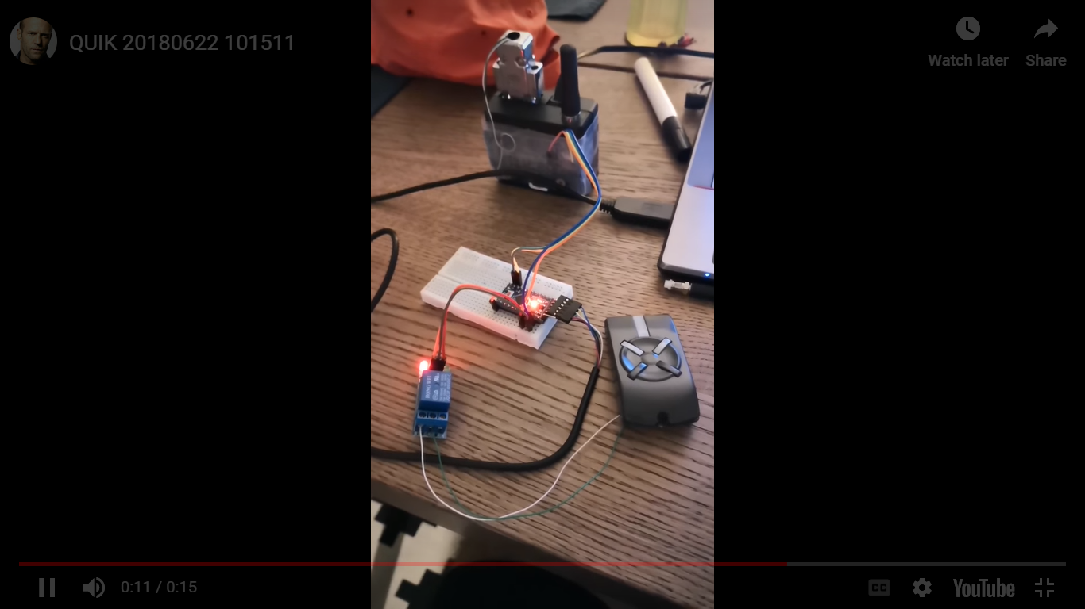

Figure 1 Garage rack mount opener with siemens

**1. THE SECOND APPLICATION WAS SECRET RACK MOUNT OPENER**

This is a mechanism rack mount that opens the rack mount from the inside after receiving a secret combination from the outside This framework is wired to such an extent that you can tap on the entryway's peephole in a particular succession. Assuming you get the combo right, the entryway opens! No keys required. The undertaking utilizes a stepper engine and stepper driver to open the entryway, and a capacitive sensor to detect taps on the peephole.

Am going to share this screen shoot and some limitation of this secrete rack mount opener

And after that all I show you what decision we have taken to improve some applications like this one!.

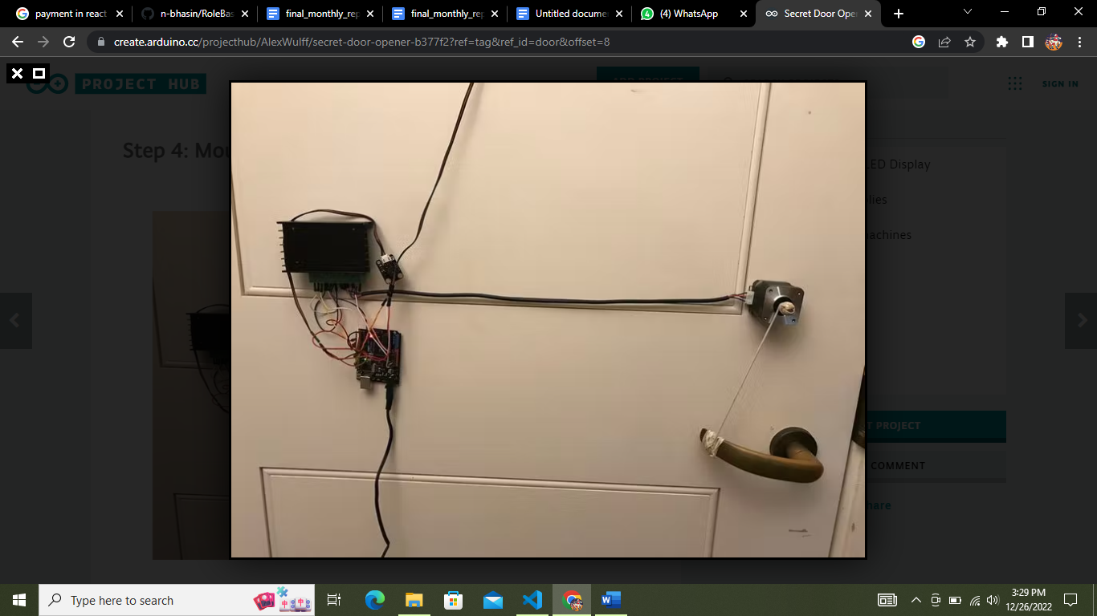

Figure 2 secret rack mount opener

One limitation of this framework is that you'll have to approach a power source to connect the 12V connector. Consequently, I set the engine driver, Uno, and Bell on the left half of my entryway near the pivot. Along these lines, the rope coming from the wall doesn't impede opening the entryway.

Another limitation is that the engine ought to have the option to be mounted straight above or underneath the finish of your entryway handle. he was not completely certain if this framework could chip away at handles; it's vastly improved fit to handles like the one displayed in the photographs above.

### KEYPADS

The most basic types of ID readers are keypads, based on simple twelve-digit keypads, containing the numbers 0-9 .

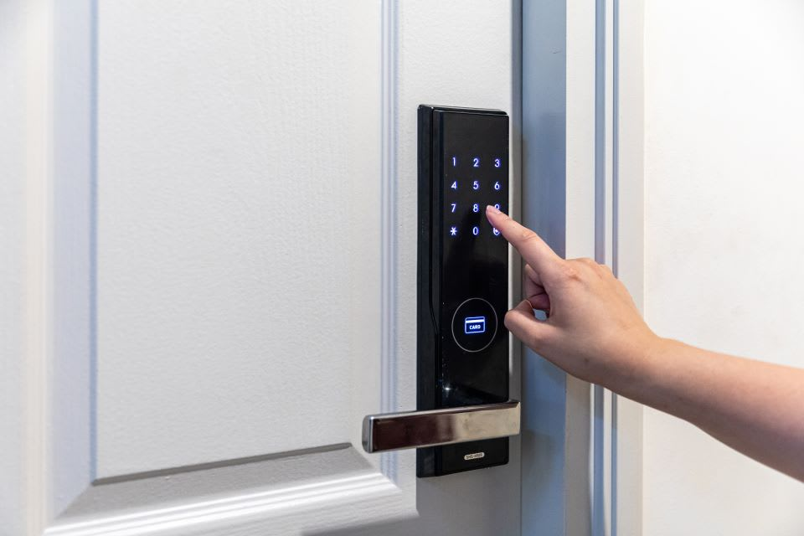

Figure 3 keypads system

These types of access control locks are very simple and cheap, and over time they have advanced to include some more secure functionality, like scrambling the LED number keys on the keyboard so that others who can detect the gesture and movement wouldn’t be able to use it.

* The main disadvantage include people’s need to share the code, like with package or food delivery or friends. If people share this code, you can’t really know how many people have access or who accessed the keypad at what time.

We are going to provide a special defence security to rack mounts that can be

Opened throught the website where you can authenticate to whom entered in the house and the manager can track the date and time person opened the house and the time also he closed the house as we will provide the credential to any one want to enter in the house.

# RESEACH METHODOLOGY

## INTRODUCTION

This chapter contains the methodology and the basic foundation used to carry out this project. The project is based on four main phases: Feasibility study, Design of Waterfall Model, Implementation of Design and Testing. The first two steps will be completed in the given order while the last two steps will be implemented iteratively. This structure will hopefully hamper risks and inconveniences associated with the project, such as wrongly implemented code or misgivings regarding the Waterfall Model. It will also give a greater understanding of the problem definition and will help set the project's outlines and delimitations.

An agile methodology was therefore chosen, instead of applying methodologies such as the Prototype model, which has a rigid, non-iterative approach.

## WATERFALL MODEL

Waterfall Model consists of a number of dependent phases that are executed in a sequential order. The complete solution is not released until the final phase. A phase starts only when the previous has completed; each phase is addressing a separate concern, there is no feedback.

Our project followed this model as we have passed through finishing one part and continue to another part until we finish them and test them together so we get the final result by implementing one by one. Eg: we first finish Iot system and after we take web part then finally we put then together. Here is the flow of waterfall model requirements.

REQUIREMENT ANALYSIS

SYSTEM DESIGN

PROGRAM DESIGN

CODING

UNIT & INTEGRATION TESTING

SYSTEM TESTING

OPERATION MENTANANCE

Figure 4 Waterfall model

## WHY WE CHOOSE WATERFALL MODEL

We chose this model because it a way separating steps of developing project and implemented one by one until the end.

Waterfall model is best model because, It’s doesn’t return back on firstly step

### FIRSTLY WE DEFINE REQUIREMENT ANALYSIS

This steps it show the tools used in project and identify how it used and where applied in implementation and what technical term used to reform new thing.

In this phase we list computer, power, servo motor, NodeMCU, breadboard, wire, and other software requirement such as React JavaScript for code implementation, NodeJS for backend side, JSON data for keeping data, vercel for hosting.

## HARDWARE AND SOFTWARE REQUIREMENT

The following hardware requirement needed for better performancing smart server locker for daily users.

|  |  |
| --- | --- |
| HARDWARE REQUIREMENT | SOFTWARE REQUIREMENT |
| 1. Operating system : window(10,11,8,7), Linux, mac, and other 2. Microprocessor: intel, cache 2MB,or above 3. RAM: 1MB minimum 4. 2GB or more Hard disk free space 5. Every phone browser 6. Servo motor 7. Led 8. NodeMCU | 1. An web browser 2. WIFI (Host sport) 3. JSON Data 4. Arduino IDE 5. React NodeJS 6. C++ 7. HTML 8. CSS 9. Vercel for hosting |

Table 1 Hardware And Software Requirement

### SYSTEM DESIGN

In this phase, the system is designed based on the requirements gathered in the previous phase. The design should include a detailed specification of the system's architecture and components.

We apply This step after define requirement analysis and design all phase needed to implemented as define port and pin used to connect all component like state servo pin in Arduino board.

This phase used to define structure of system and organization.

### PROGRAM DESIGN

In this phase we declaration language used to implement and chose better programming language

We start to coding like install Arduino library and include board library and part of software we identify how linking web to hardware system using NODEMCU microcontroller module.

### CODING

After programming design we implement and practical code in real device

We made sample code as test servo rote in angle like 900 as right angle.

This case we define c++ in Hardware coding and we used in software are react, node, json,..

### UNITY &INTEGRATED TESTING

After coding we test function and task to move rack mount in angle using servo motor code.

Once the software has been implemented, it is tested to ensure that it meets the requirements specified in the first phase and functions correctly

### SYSTEM TESTING

After test code of hardware we test hall system like user login and logout in system.

After the software has been tested and found to be working correctly, it is deployed to users.

### OPERATION AND MAINTENANCE

After test hall system we troubleshoot same error and correct well. In this phase we press ON to open a rack mount and press OFF to close rack mount. And check in database when and who function that action.

## SYSTEM ANALYSIS

Data used in this research project have been collected from IPRC Kigali Server Staff book.

## DATA COLLECTION AND PROCEDURES USED

In order to get all the relevant data or information for this research project, some methods of data collection procedures and techniques were used. For the collection of primary data, observation and interviews were carried out. Secondary data have been collected from internet and others’ researches.

## PRIMARY DATA

### INTERVIEW

This purposeful conversation between interviewer and respondents aims at eliciting certain information from the later.

During my research, two types of interviews were conducted:

-Structured interview: This is a set of pre-defined questions directed to respondents. The main respondents to these interviews were both the IPRC Kigali server staffs such (Gaspard GAFEZA) and students we take ten students who study Information Communication Technology in IPRC kigali.

-Unstructured interview: Here, interviewer is allowed much greater freedom to ask supplementary questions, change the sequence of questions or omit certain questions if the situation so requires.

### OBSERVATION METHOD

This method is scientifically used for checks and controls on validity and reliability. The main advantages of it are that, if done accurately, the researcher look him/herself instead of asking respondents. Moreover, the information obtained under this method relates to what is currently happening. So, I went so many times to Server room and I observed what was going on.

## SECONDARY DATA

Secondary data are data collected and analyzed from someone else. During our research, in order to compare and make a rational analysis and also come up with relevant conclusions, some books, others’ related researches and reports, as well as internet sources were used.

## RESULTS FROM ANALYSIS

After analyzing the existing system, the following have been pointed out: Server has code and name

## TOOLS OF DATA COLLECTION

During this final project, we collect the necessary information from lectures and students, using

bias and the difficulty of accurately and consistently measuring or recording data

## CASE STUDY

In this case, we were taken into IPRC KIGALI to observe how user open the server rack mount we have found that they use manually opening and closing the server rack mount so manager or admin can must be averable on the site to provide the key which is time consuming (time wastage) , is that why we tried to look and implent how admin and user can opend and close ther server rack mount through simple aunthonticated website . So we need an IOT and web site for opening and closing server rack mount.

# SYSTEM ANALYSIS AND DESIGN

## I**NTRODUCTION**

In order to build a strong and successful system that meets the user needs, the development of a system is a work which requires much effort and attention. Actually, the main goal of a new system is to satisfy the needs of its users by solving problems they face with the existing system. Deep analysis of user’s needs will most of the time lead to a useful software development as a system might give perfect result.

The objective and the purpose of this chapter is to design and analyse our system to meet the user requirement before implementation , we pursist look about all stage and strategies to confense and meet the user needs.

## SYSTEM ANALYSIS

The architecture of the whole project is analyzed. System analysis is the process of defining the architecture, components, and data of a system to satisfy specified requirements. Design is a method of studying a system by examining its component parts and their interactions. Before implementation began the system was analyzed and designed. In this section, use cases, requirement analysis, and other part are described in details. [1]

## REQUIREMENT ANALYSIS

smart server rack mount lock will use the following requirements. This has mainly two actors. Those are Admin and user. This website will allow user to direct user according to the role defined for example user will be directed to the user dashboard and admin will be directed to admin dashboard.And we will need IOT device to control the functionality of opening and closing the rack mount electronically And after we connect them to the web site.

Here are some requirements analysis techniques that you can use to capture requirements:Hold One-on-One Interviews, Use Focus Groups, Utilize Use Cases, Build Prototypes, Define Requirements Precisely, Prioritize Requirements, Carry Out an Impact Analysis, Resolve Conflicts. We focus only one on one Interview.

## **DATA REQUIREMENT**

During requirement analysis the following data have been identified for user and admin, the system needs to have user and admin data to be able to work, where we will need userId, username, user-password, user phone number and capture the date and time . we will need server records like server Id , server Name and server Code to be able identified with others.

## PROCESS REQUIREMENT

Our application has the following process where user and admin needs to be registered. first we will need to register user inorder to allow user to login in the system , after registering the user then user is able to login and if the password and email mutch with the stored data user will be directed to user dashboard. if user or admin has invalid user email and password are dismatch they will be redirected to home page . admin needs to have user and password and if admin password and email match with existing one the admin will be redirected to the admin dashboard.

Secondly: we must store the server content mean admin must add server to allow user to find the server to be switched ON or OFF and system will need to capture the date and time user opened and closed the serve

## FEATURES

User and Admin has the same login , A separate page is where Admin page that allow admin to view all details , add, delete, update user and server , where user is able to view and switch server only.

A valid login is required for all process to be performed. A valid login is required for every registered users and admin. All of them have a valid user id and password. system will authenticate their valid login.

## CURRENT SYSTEM PROBLEMS

Due to the existing means being used we have seen according to the sample we have taken (IPRC KIGALI) we have seen that they close server rack mount (server rack mount) by manualy open and close the rack mount and manager can’t not be able to know exactly user who open and close the rack mount , we didn’t found this functionality and there is no system that can track the time user has been opened and closed the rack mount .

The existin system has no way to record the usage of servers and they can not be able to check the time server has been used for example the server manager can not now the server which have been accessed more time than others.

### EXISTING USER CASE DIAGRAM

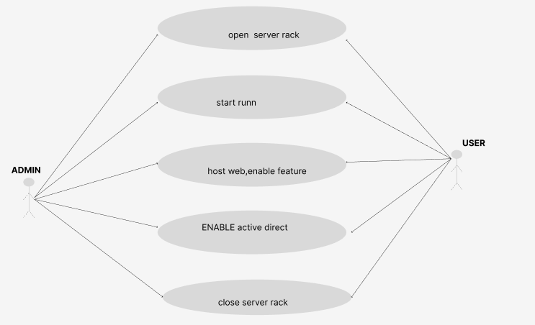

Figure 5 old user case diagram

## PROPOSED NEW SYSTEM SOLUTION

Our Web and IOT system can not handle the SMS short way to inform the admin for simplicity and if this system is android based can be better for accebility to any one and if this system can track the server which is on and sever which is off can be better achievement , we are pleasure and happy to inform you that all this functionality can be possible according to what we have achieved and tested. so if you are interested you can proceed.

### CURRENT USER CASE DIAGRAM

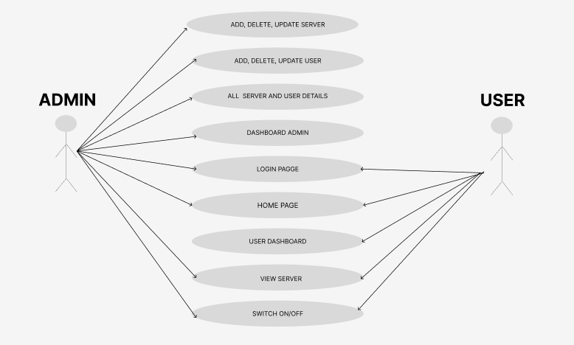

Figure 6 current user case diagram

## SYSTEM DESIGN

is the process of defining the architecture, components, modules, interfaces, and data for a system to satisfy specified requirements. System design is done from study of the existing system in order to determine what changes will be needed to incorporate the user needs that were not met by existing one.

## DATABASE SCHEMA AND ERD

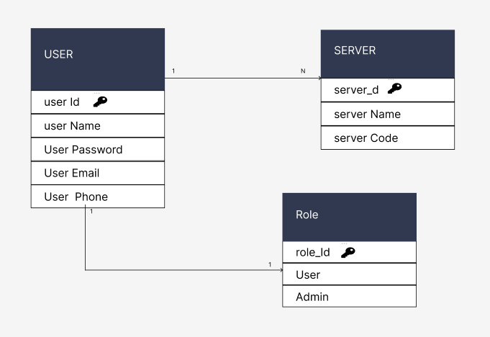

Figure 7 entity schema diagram

## FLOW CHART DIAGRAM

START

HOME PAGE

IF(USER==ADMIN)

ADMIN DASH

VIEW & DELETE DETAILS

STOP

ADD, DELETE, EDIT, USER

ADD , DELETE & EDIT SERVER



NO

Figure 8 Admin dashboard flow chart

## USER DASHBOARD FLOW CHART

START

HOME PAGE

IF(USER==BASIC

USER DASHBOARD

SWITCH ON/OFF SERVER

STOP

ADD , DELETE & EDIT ERVER

NO

YES

Figure 9 User dashboard

## USE CASE DIAGRAM



Figure 10 use case diagram

# SYSTEM IMPLEMENTATION

## DESIGN AND IMPLEMENTATION

This servo it help to rotate a rack mount for open and close so we need web application to manager it very well as an full IOT.

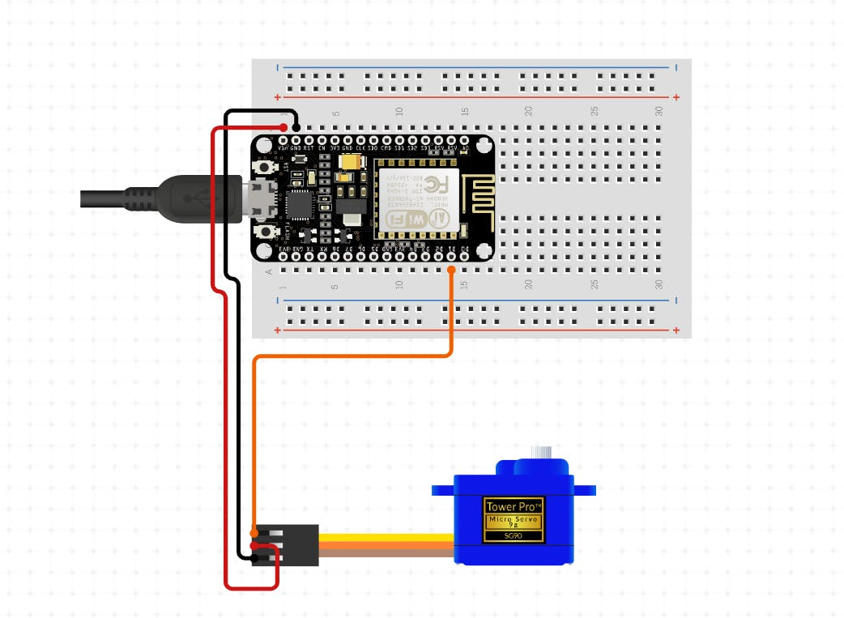

Figure 11 circuit

## HOME PAGE

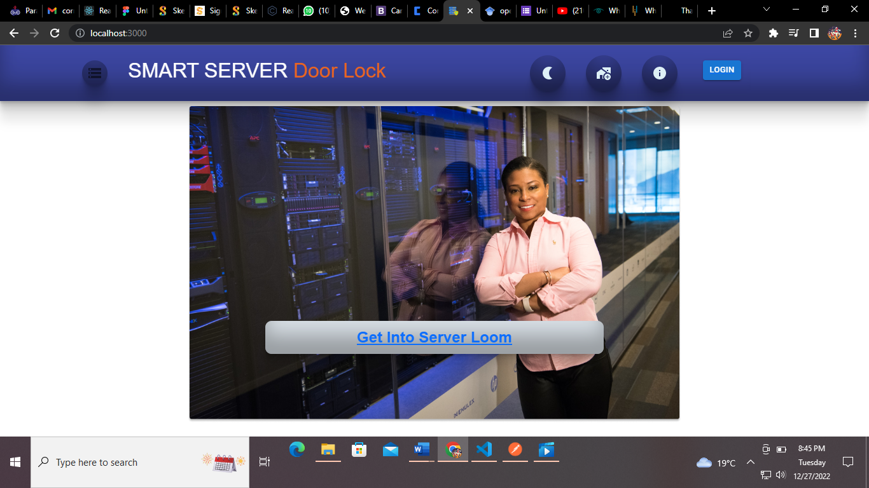

Figure 12 homepage

## LOGIN PAGE

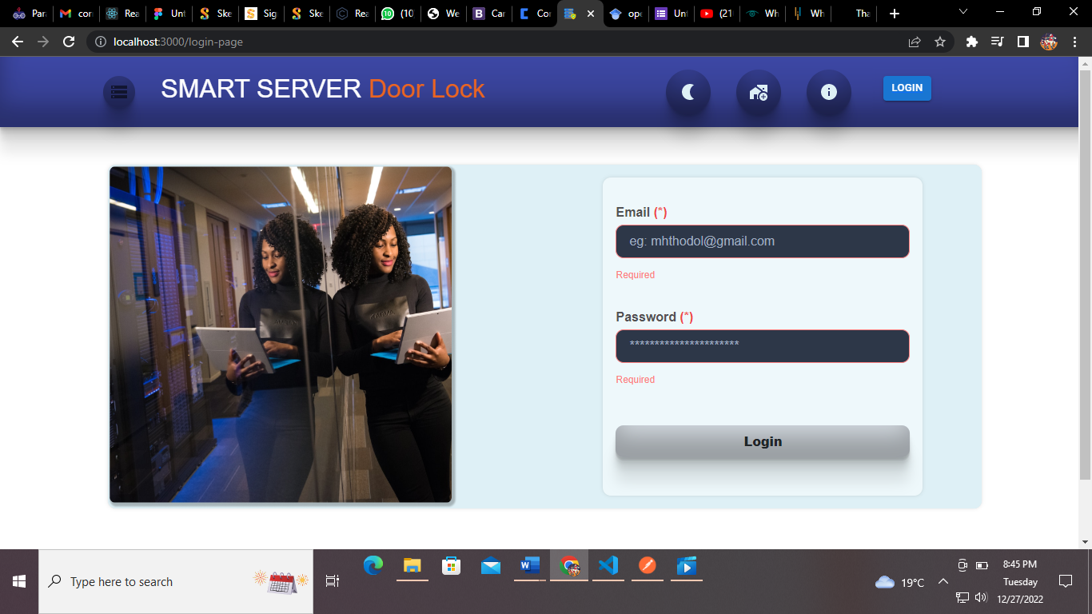

Figure 13 login page

## ADMIN DASHBOARD

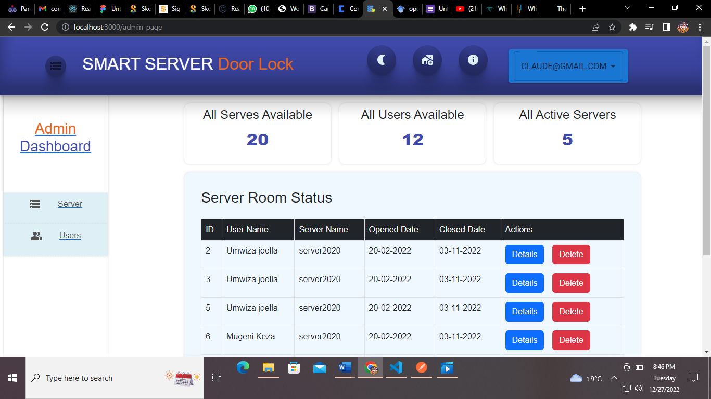

Figure 14 admin dashboard

## ADD NEW SERVER

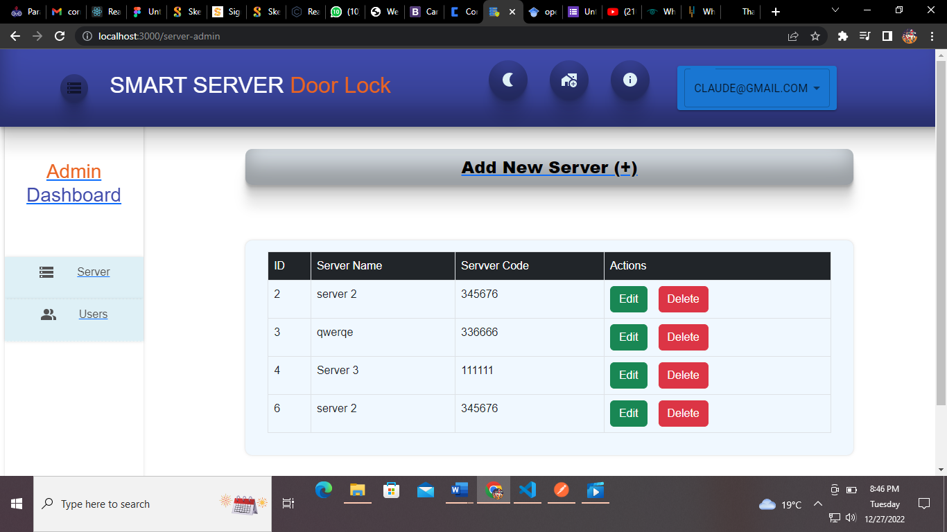

Figure 15 add server

## USER DASHBOARD

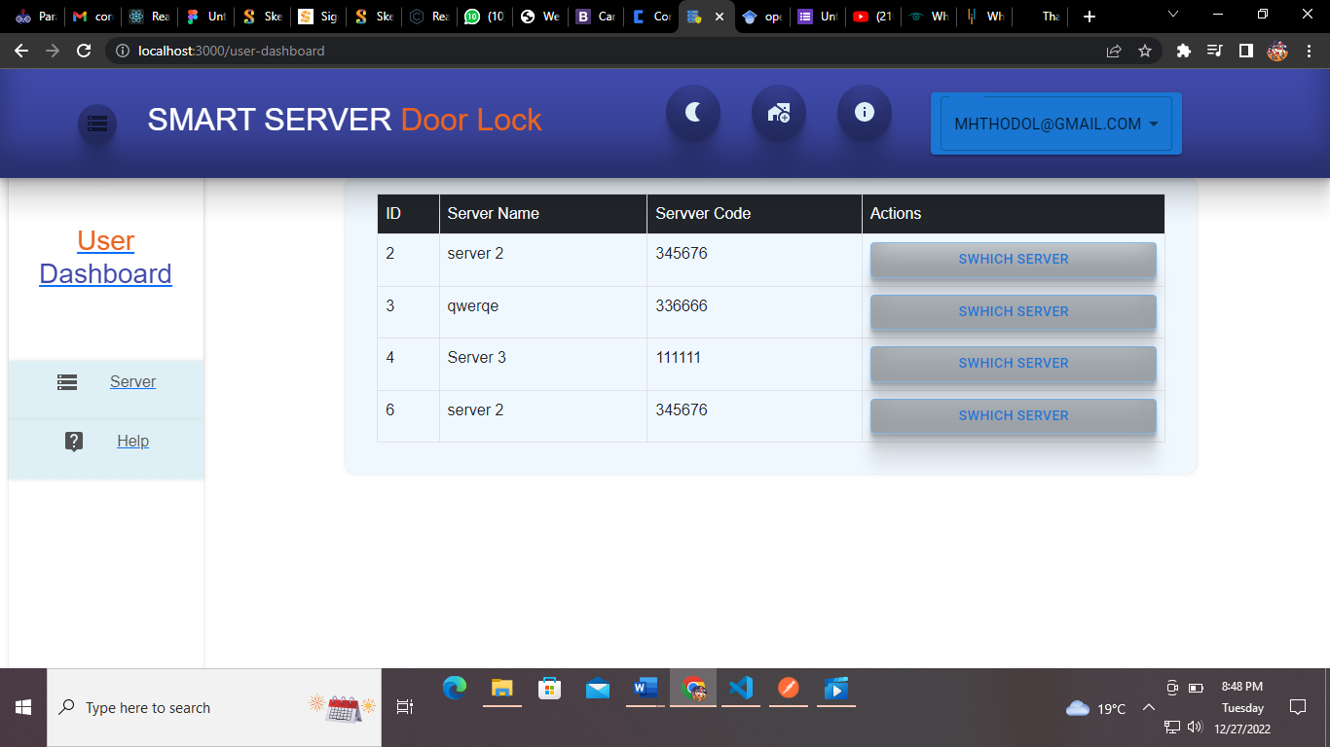

Figure 16 user dashboard

## SWITCH ON/OFF SERVER RACK

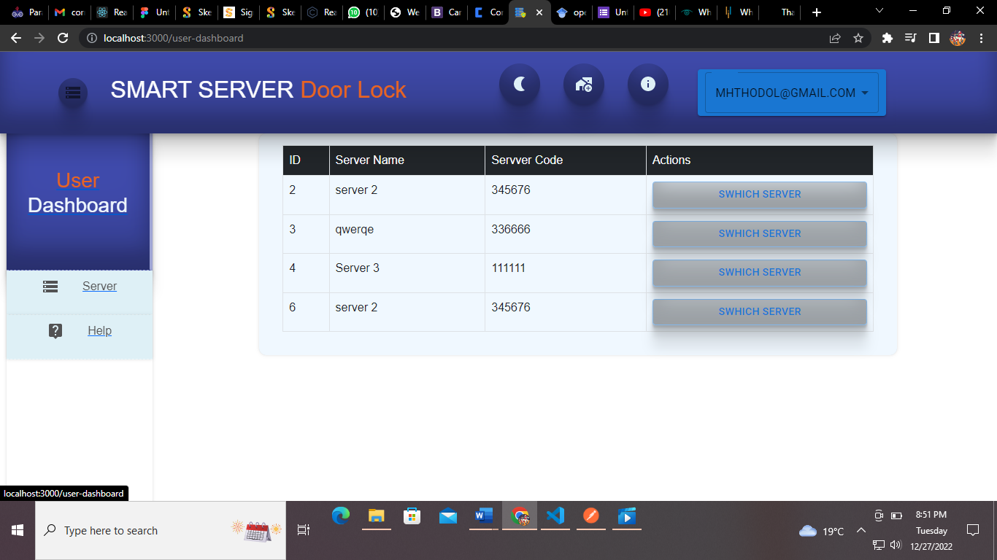

Figure 17 switch on

# CONCLUSION AND RECOMMENDATIONS

## CONCLUSION

As a conclusion of our project and as the objective of a project has been achieved which has been developing hardware for controlling automated rack mount opening and closing rack mount system, The demand for the automatic operation of a device increases, it is more preferable over manually operation of rack mount operation. Here we are controlling the ON/OFF operation of rack mount opening or closing by push button or automatically by servo motor. This is interesting because it performs work in accurately also it involves technology that is improve our skills for us and for many industries, Markets here in Rwanda and abroad if is taken in use. We did a group work with the help of our supervisor and the other department members; we were so close in success of this project. By the end of this project, we gained skills and knowledge about the research.

## RECOMMENDATION

Our recommendations are consider into two part:

The firstly we recommend academic calendar for prepare full IOT module due we study Raspberry pi only but IOT it contain more microcontroller so we need improvement of internet of things skills like NodeMCu, Arduino(UNO, MEGA),etc

Secondary we plan this system will improved into android app whenever to access without web application .we recommend that for make SSL high we replace servo motor into solenoid sensor due it functional than motor to open and close a rack mount easy.

# References

|  |  |
| --- | --- |
| [1] | A. A. K. D. K. R. S. V. S. a. E. S. Škraba, Prototype of group heart rate monitoring with NODEMCU ESP8266, Chicago: 6th Mediterranean Conference on Embedded Computing (MECO), 2017. |
| [2] | K. A. e. a. Patil, Smart door locking system using IoT, MLA: International Research Journal on EngTechnol (IRJET), 2020. |
| [3] | h. claude, Smart server security system, kigali: iprc Kigali, 2022. |
| [4] | K. Aditya, "projecthub," MEMBERS WHO RESPECT THIS PROJECT, 2 May 2020. [Online]. Available: https://create.arduino.cc/projecthub/kumaraditya303/esp8266-servo-controller-3966bc. [Accessed 10 10 2022]. |
| [5] | D. A. ·, "https://www.circuito.io," circuito, 2015 . [Online]. Available: https://www.circuito.io/app?components=513,9590,9591,10190,360216. [Accessed 18 09 2022]. |
| [6] | U. Shaked, "wokwi.com," He co-organizes the IOT, 20 jan 2020. [Online]. Available: www.wokwi.com. [Accessed 03 12 2022]. |
| [7] | "library.ucmerced.edu," library.ucmerced, 19 6 2020. [Online]. Available: https://library.ucmerced.edu/data-dictional. [Accessed 21 11 2022]. |
| [8] | Clottilde, Research methodology requirement, KIGALI: research, 2019. |
| [9] | Πλίτσης, Ζ, Customizable middleware framework for accessing mobile sensors, Πλίτσης, Ζ, (2006). |
| [10] | Suravase, V., Shinde, V., Shirsat, D., Diwate, S. S., & Palhe, Automation of Door Opening & Closing, 2021. |
| [11] | Dmaidi, F., Salman, N., & Darweesh, CELL PHONE BASED DTMF CONTROLLED GARAGE DOOR OPENING SYSTEM., 2014. |
| [12] |  |
| [13] | Gordon, W. J., & Newell, G. F., Closed queuing systems with exponential servers. Operations research, 1967. |
| [14] | labrary server management, kigali: direct library and academic resource, 2019, p. 122. |

# APPENDEX

1. #include <ESP8266WebServer.h> // Include the ESP8266WebServer library
2. #include <Servo.h> // Include the servo library
3. Servo myServo; // Create a servo object
4. ESP8266WebServer server(80); // Create a web server on port 80
5. void setup() {
6. myServo.attach(D2); // Attach the servo to pin D2
7. server.begin(); // Start the web server
8. Serial.begin(115200); // Initialize the serial port for debugging
9. }
10. void loop() {
11. server.handleClient(); // Listen for HTTP requests
12. }
13. // This function is called when the web server receives an HTTP GET request
14. void handleRoot() {
15. String message = "Hello from the NodeMCU!\n"; // Build the response message
16. message += "Send an HTTP POST request with a body like this: {\"angle\": 90}\n";
17. message += "to set the servo angle to 90 degrees.";
18. server.send(200, "text/plain", message); // Send the response
19. }
20. // This function is called when the web server receives an HTTP POST request
21. void handlePost() {
22. // Parse the request body to get the servo angle
23. DynamicJsonDocument doc(1024);
24. DeserializationError error = deserializeJson(doc, server.arg("plain"));
25. if (error) {
26. server.send(400, "application/json", "{\"error\":\"Invalid request body\"}");
27. return;
28. }
29. int angle = doc["angle"];// Set the servo angle
30. myServo.write(angle); // Send a response
31. String message = "Servo angle set to ";
32. message += angle;
33. message += " degrees.";
34. server.send(200, "text/plain", message);
35. }
36. void setupRoutes() {
37. server.on("/", handleRoot); // Set up the root route to call handleRoot()
38. server.on("/", HTTP_POST, handlePost); // Set up the / route to handle HTTP POST requests with handlePost()
39. }

This code sets up a web server that listens for HTTP GET and HTTP POST requests on the root URL (/). When it receives a GET request, it sends a simple message with instructions for how to control the servo. When it receives a POST request with a JSON body like {"angle": 90}, it sets the servo angle to 90 degrees.

To control the servo, you can send an HTTP POST request to the NodeMCU using a tool like curl or a web browser extension like Postman. For example, you can use the following curl command to set the servo angle to 90 degrees: